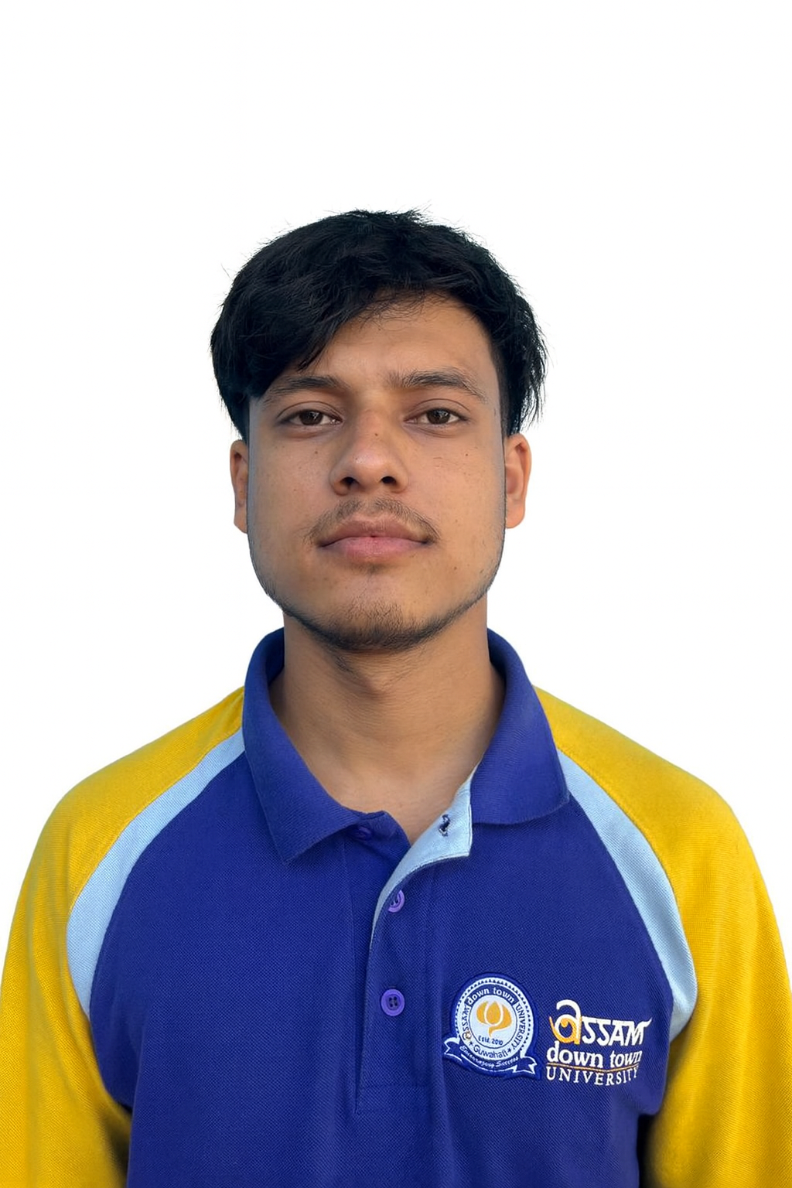

Passport size photo graph
Bipin Thapa 
Phone no: 7085510991
Email address: bipinthapa835@gmail.com
LinkedIn Profile: https://www.linkedin.com/in/bipin-thapa-46160728a
KEY SKILLS
- Communication Skills
- Problem solving
- Critical Thinking
TECHNICAL SKILS
- Programming Languages – C, Python
- Cyber Security
ACADEMIC QUALIFICATION
Year | Degree | Institute | % / CGPA
2027 | B.Tech(CSE) | Assam Downtown University, Guwahati | Pursuing
2023 | 12th (CBSE) | Radiant Star Education Centre | 79%
2019 | 10th (BSEM) | Chil Chil Asian Mission School | 63.5%

 | PROFESSIONAL QUALIFICATION
Courses |  | University | Year | Percentage
Qualitative Research Design |  | Emory University(Online) | 2024 | 94%
Programming With  Javascript |  | Meta (Online) | 2023 | 97%

INDUSTRIAL TRAINING/ INTERNSHIP

PROJECTS
PROJECT | YEAR | UNIVERSITY
FIRE ALERT SYSTEM | 2023 | Assam Downtown University
INVENTORY  MANAGEMENT SYSTEM | 2024 | Assam Downtown University

ACHIEVEMENTS
- Selected in first round of Inter University Smart India Hackathon, 2024
- Selected in first round in Innovathon Hackathon , 2024

EXTRACURRICULAR ACTIVITIES
- Gymnasium
- Football
- Cooking

OTHER INTERESTS
• Interest in travelling

PERSONAL DETAILS
- Date of Birth: Feb 14th , 2004
- Father’s Name: Mr. Ganga Bahadur Thapa
- Permanent Address: Kanglatongbi, Vijaynagar, Manipur

Declaration:
I do hereby declare that all the information stated above is true to the best of my knowledge and belief.


Date: 21/11/2025
Place: Guwahati

